Supplementary Information for “An assessment of oxbow lakes and their potential in reconstructing past river discharge: Implication to reconstruct past climate in Southern West Bengal.”
Vibhuti Shivsager¹, Dipjyoti Basumatary¹, Chandreyee Goswami², Mahadev³, Saurabh Singh⁴, Manoj K. Jaiswal¹*
¹Department of Earth Sciences, Indian Institute of Science Education and Research (IISER)
Kolkata, Mohanpur, Nadia, West Bengal, India.
²Institute of Rock Structure and Mechanics, Prague, Czech Republic
³Inter-University Accelerator Centre, New Delhi, India
⁴Department of Geology, Institute of Earth and Environmental Sciences, Dr. Rammanohar Lohia Avadh University, Ayodhya, Uttar Pradesh, India

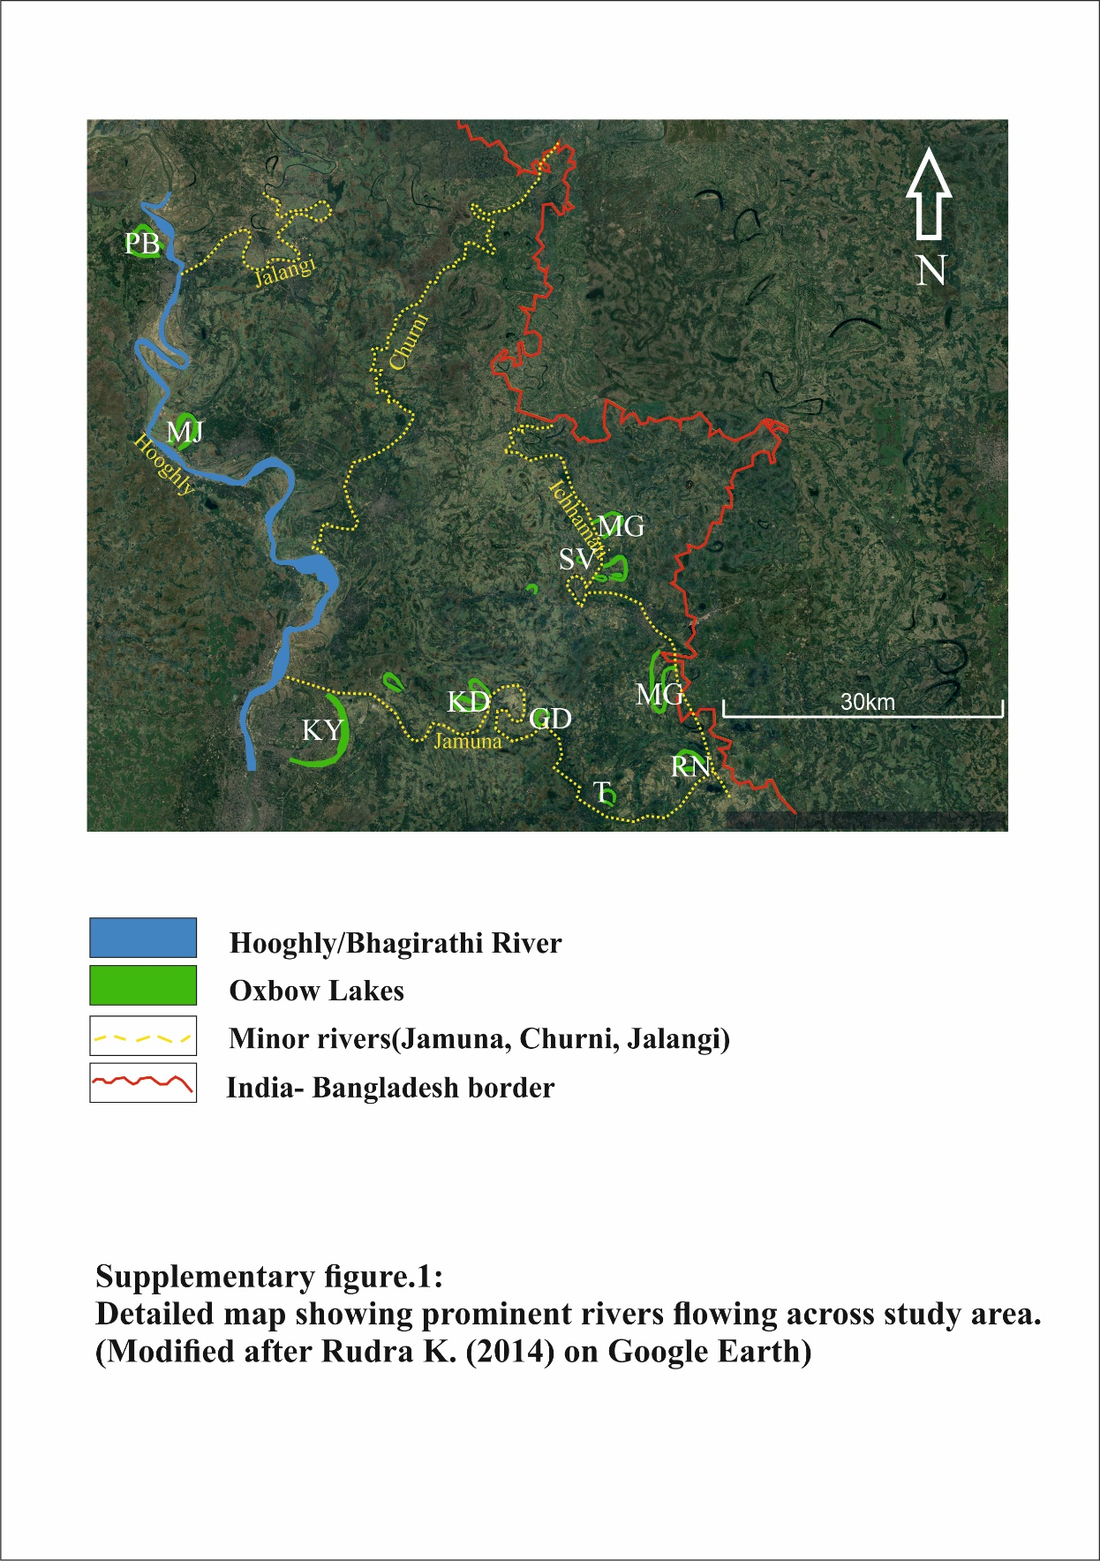
Supplementary figure. 1: River map (as mentioned in the main manuscript)
The image above shows the major and minors rivers, that flow across the study area. Hooghly (Bhagirathi) flows southward and is a major active river. Jamuna and Icchamati rivers gets are not active ones as they occasionaly gets discharge during flood time or high discharge events. Ten out of 16 oxbow lakes are also visible in the image. Different oxbow lakes belonging to Hooghly, Jamuna and Icchamati have been sampled for the proposed work.

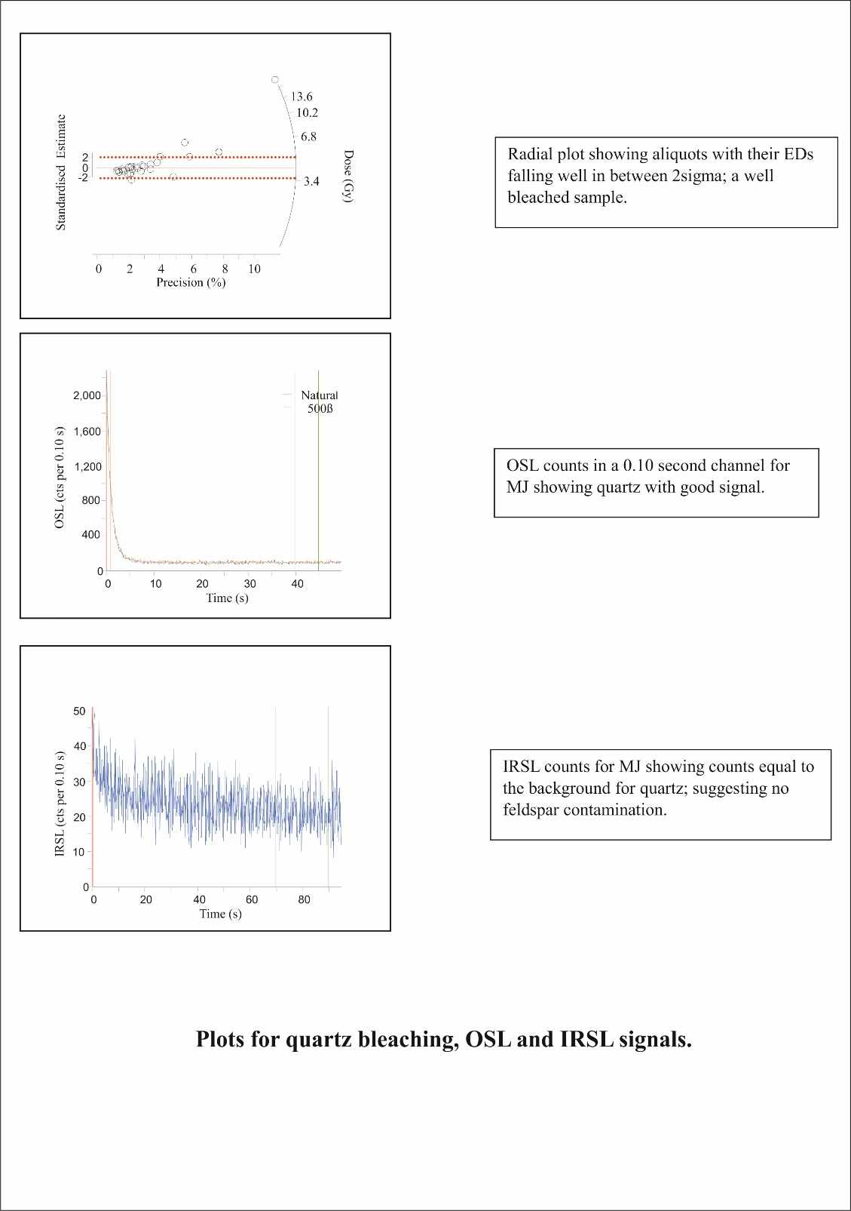
(c)
(b)
(a)
The supplementary figure for Tests for Quartz bleach and Feldspar contamination

The attached image shows that the quartz used for luminescence dating is fairly bleached (a), and feldspar contamination was in the tested sediments for dosimetry (c).
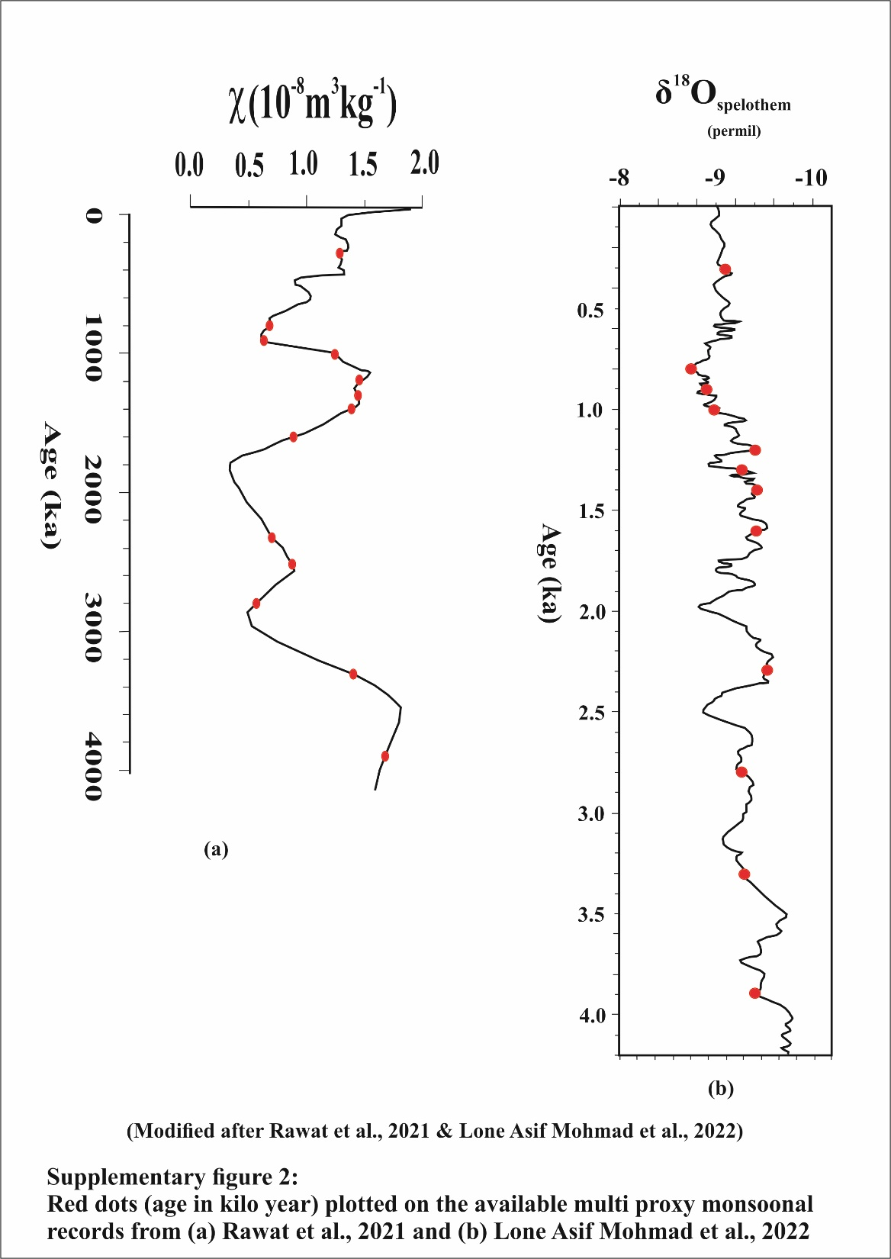
Supplementary figure.2: Graph for paleo monsoon correlation (Rawat et. al., 2021; Lone et. al., 2022) (as mentioned in the main manuscript)

Plots attached in the image have been used for the correlation of our dates associated with sedimentary structures and discharge values to interpret the monsoonal fluctuations in the past for the study area. Inferences based on Magnetic susceptibility and Oxygen isotope ratios were compared with our interpretations in terms of past discharge variability and climatic fluctuations.
Note: No magnetic susceptibility or Oxygen isotope study was carried out in present study. It has been just plotted with dates to make the inferences in coherence with the work of Rawat et. al., 2021 and Lone et. al., 2022.

